Backyard Campout Packing List
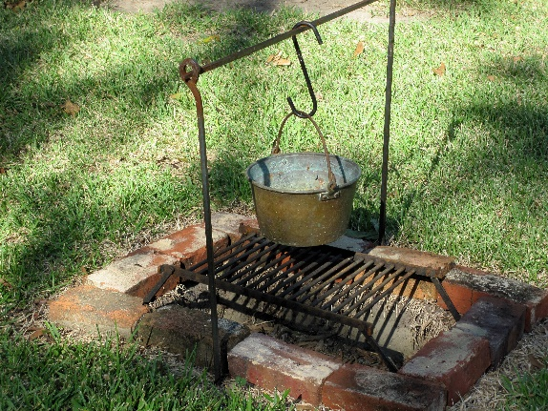

Tent
Tarps to keep tent dry in the event of rain,
Tent stakes,
Hammer or rubber mallet to drive stakes in,
Sleeping bags & pillows,
Closed cell foam sleeping pad, inflatable mattress or cot for each person,
Clothing for daytime, evenings at the campfire, and to sleep in,
Camp chairs or logs to sit on,
Hat & sunglasses,
Fire bowl, or bricks/rocks to build fire ring,
Wood for campfire,
Cooking grate if you’ll be cooking over fire,
Cooking utensils, pots, pans, plates, cups, napkins, silverware,
Food prepped for easy outdoor cooking over the campfire or on a propane grill or stove, or plans for take-out to be delivered,
Cooler with ice for keeping food/drinks cold,
Flashlights and/or head lamps,
Sunscreen, Bug Spray, & Hand Sanitizer,
Water for drinking and food prep,
Hygiene essentials (deodorant etc),
Journal or notebook to write about your camping experience,
Books, coloring books & crayons, cards, games, frisbee,
Don’t forget to plan for your pets too including their bed, food, treats, leash & collar etc.
Charging device for phones (please send us your camping photos!),
Trash can and garbage bags,
Ziploc bags for leftover food,
Paper towels, napkins, towels, scrubbing pads, etc.,
Wash bucket,
Charged hose.

