Easy Aluminum Foil Prep-Ahead Recipes for Camping

The easiest way to cook while camping is to prep at home before you go. Here are some delicious ideas that can be prepped ahead of time.

BREAKFAST IDEAS

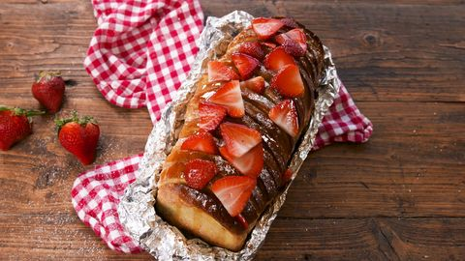
Campfire French Toast: https://www.delish.com/cooking/recipe-ideas/a20886747/campfire-french-toast-recipe/

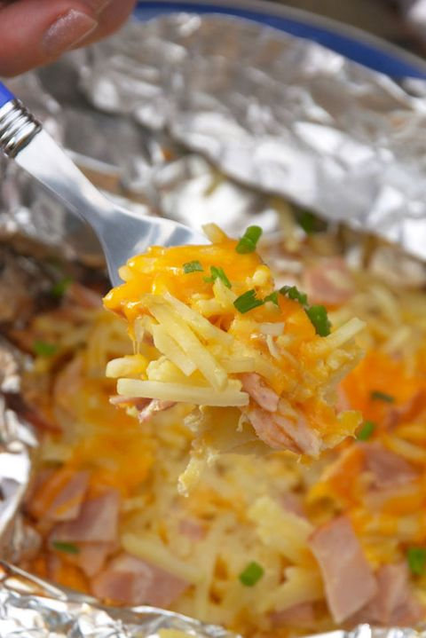
Breakfast Foil Packs: https://www.delish.com/cooking/recipe-ideas/recipes/a53625/breakfast-foil-packs-recipe/
To make this recipe vegetarian, simply leave the ham out or substitute other ingredients to make it your way!

LUNCH IDEAS

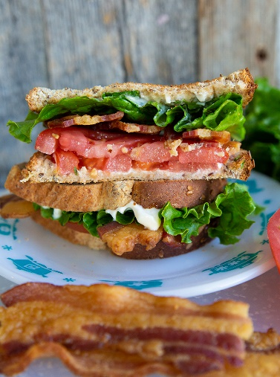
Easy sandwich ideas for lunches:
BLT – simply precook the bacon, and wash & cut the veggies in advance. Instead of bacon, substitute or add avocado!
Deli turkey or ham & cheese sandwiches or PB&J are easy options too.
Don’t forget the bread, chips, baby carrots or cut celery on the side, along with mayo, ranch dressing, or other sandwich dressings

DINNER IDEAS

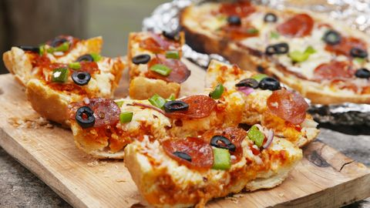
Grilled Pizza Bread: https://www.delish.com/cooking/recipe-ideas/recipes/a54636/grilled-pizza-bread-recipe/
To make this recipe vegetarian, simply leave out the pepperoni or substitute other ingredients to make it your way!

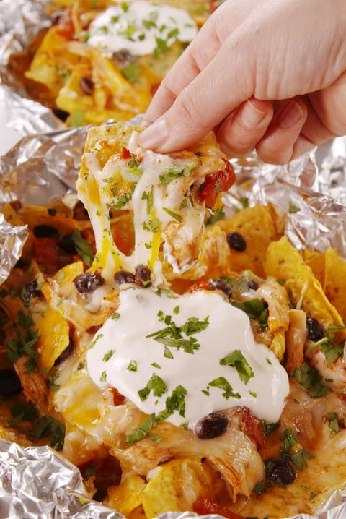
Foil Pack Chicken Nachos: https://www.delish.com/cooking/recipe-ideas/g2854/foil-pack-recipes/?slide=13
To make this recipe vegetarian, simply leave out the chicken or substitute other ingredients to make it your way!

DECADENT DESSERTS

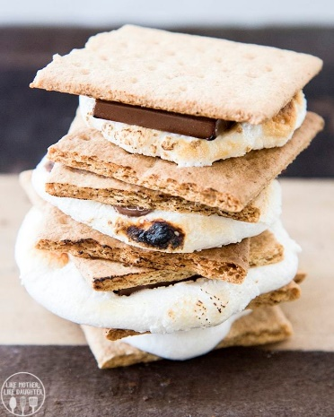
S’mores, of course! 25 different S’mores recipes, from classic to creative. https://lmld.org/ways-to-make-smores/

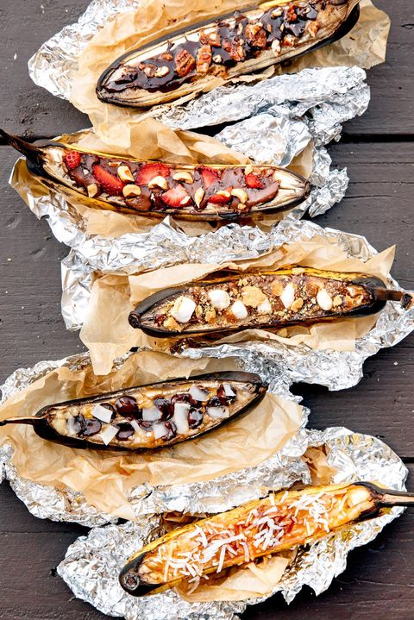
Campfire Banana Boats: https://www.countryliving.com/food-drinks/g4308/campfire-desserts/?slide=7

